

Department of CSE

B.Tech. CSE Trimester -5

2520030214
Chegireddy Thanvi

Cloud Infrastructure and Services
25CS2206E

LAB RECORD
2026

SKILL 1 CDIS
1. Aim
To create an IAM user with programmatic access only, generate and download access keys, and configure AWS Free Tier usage alerts and billing notifications.
2. Description
AWS Identity and Access Management (IAM) is a service used to manage users and permissions in an AWS account. It allows administrators to create users and provide access to AWS resources according to their requirements.
In this experiment, an IAM user is created without console access. Programmatic access credentials, namely Access Key ID and Secret Access Key, are generated and downloaded. These credentials are used for accessing AWS services through command-line tools and applications.
AWS also provides billing and cost-management features to monitor resource usage and avoid unexpected expenses. Free Tier usage alerts and AWS Budgets help users receive email notifications when their usage or spending reaches the configured limits.
3. Prerequisites
- An active AWS account.
- Access to AWS Management Console.
- Administrative permissions.
- A valid email address.
- Internet connection and web browser.
4. Procedure
Part A: Create an IAM User with Programmatic Access Only
Step 1: Log in to AWS
Open a web browser and visit the AWS Management Console. Log in using the root account credentials.
Step 2: Open IAM Service
In the AWS search bar, type IAM and select Identity and Access Management (IAM). The IAM dashboard will open.
Step 3: Select Users
From the left navigation panel, select Users. Click on the Create user button to create a new IAM user.
Step 4: Enter Username
Enter a suitable username, such as Student-IAM-User. Do not enable AWS Management Console access because the user requires programmatic access only.
Step 5: Assign Permissions
Click Next and select Attach policies directly under Set permissions. Choose the required permissions policy, such as Administrative access, according to the experiment requirements.
Step 6: Create User
Click Next, review the configuration and select Create user. Verify that the newly created user appears in the Users list.
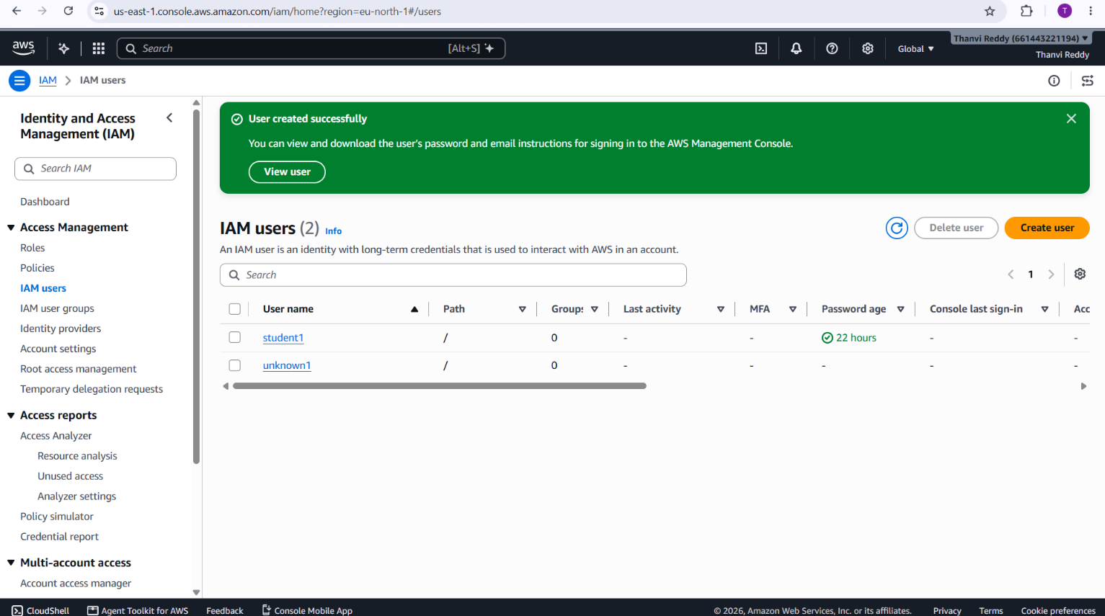
Part B: Generate and Download Access Keys
Step 7: Select IAM User
Open the newly created IAM user from the Users list.
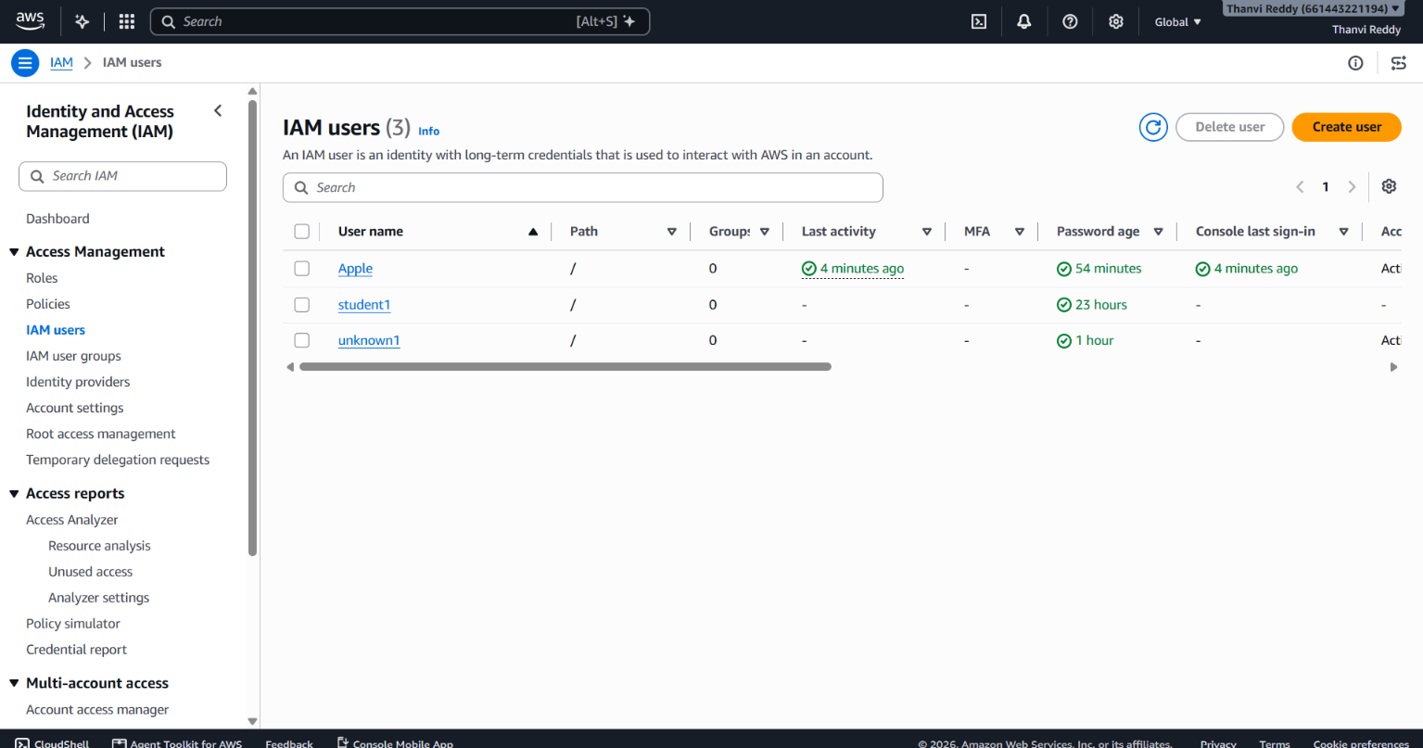
So I entered with a username called “Apple”
Step 8: Download Access Keys
The console displays the Access Key ID and Secret Access Key. Click Download .csv file to download both credentials.
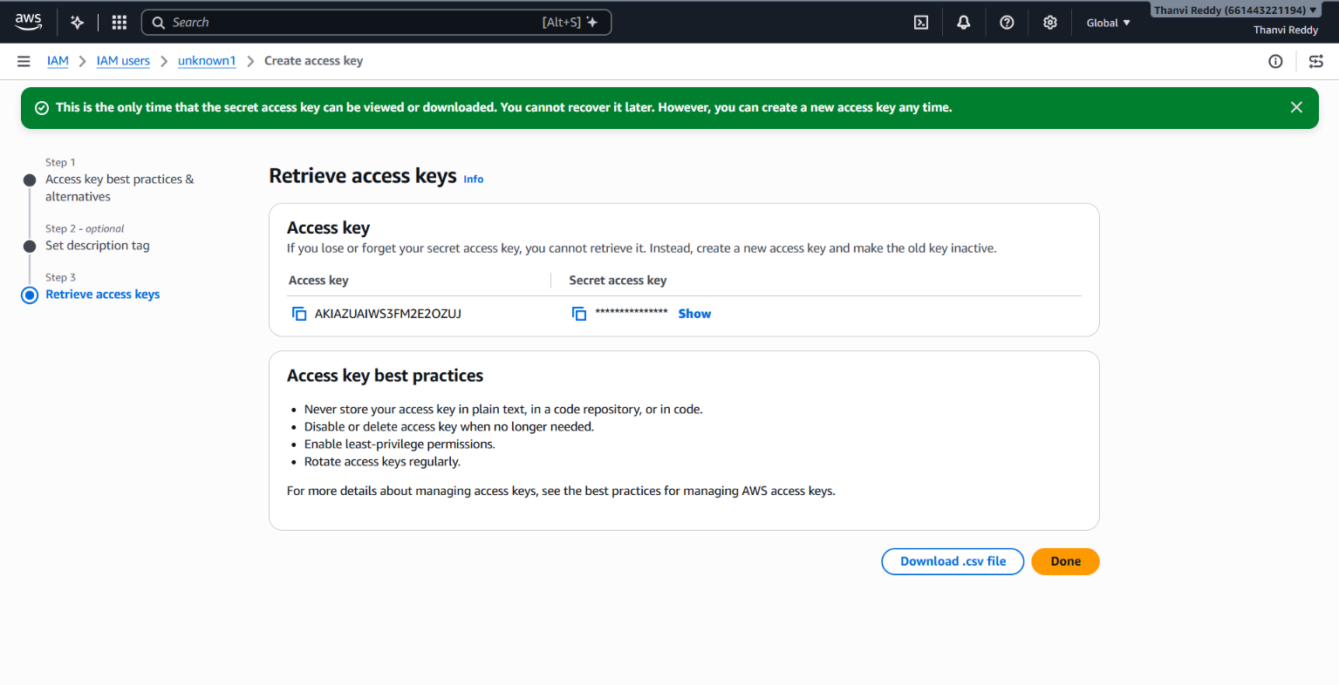

Step 9: Verify Credentials
Open the downloaded CSV file and verify that both credentials are available. Click Done to complete the process. Keep the credentials secure and do not share them.
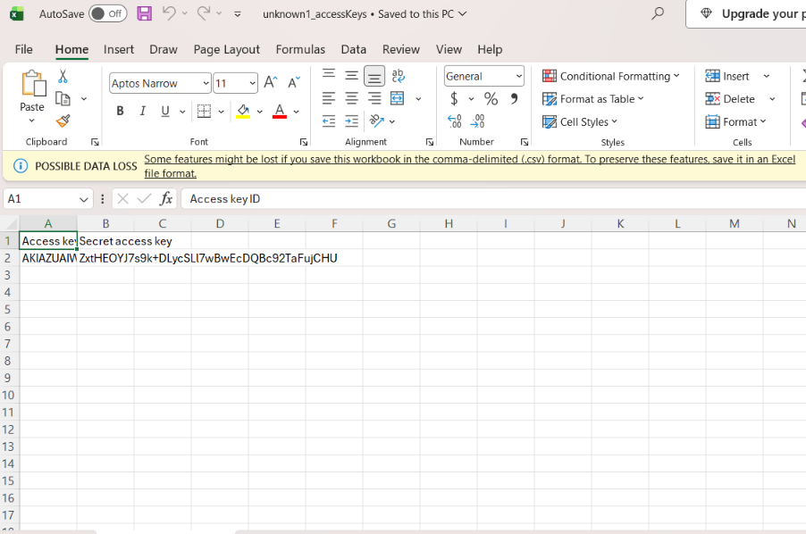

Step 10: Open Billing and Cost Management
Log in to AWS using the root account. Search for Billing and Cost Management in the AWS search bar and open it.
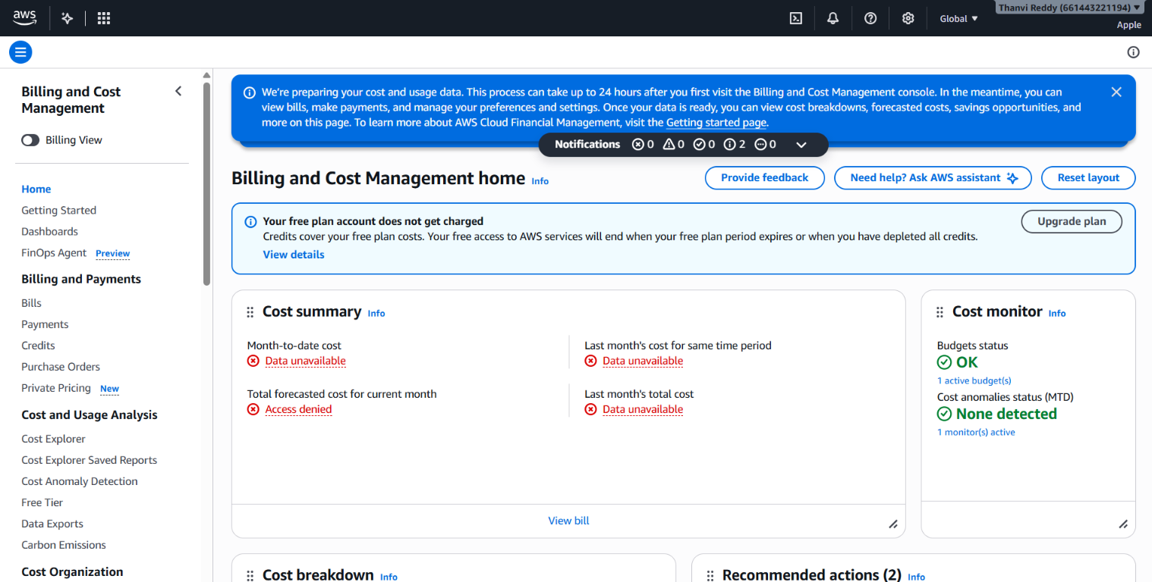
Step 11: Configure Budget Details
Enter the following details:
- Budget Name: AWS-Monthly-Cost-Budget
- Period: Monthly
- Budget Renewal Type: Recurring budget
- Start Month: Current month
- Budgeting Method: Fixed
- Budgeted Amount: $0 (example)
- Budget Scope: All AWS services
5. Expected Outcome


